**Teacher Notes for**

“**Why and How Your Body Makes Millions of Red Blood Cells Every Minute**”[1]

In this analysis and discussion activity, students learn about stem cells, cell differentiation, and how epigenetic changes and transcription factors contribute to cell differentiation. These concepts are introduced as students analyze how the body makes red blood cells. During this activity, students review aspects of transcription and translation, mitosis, and the functions of organelles.

Before beginning this activity, students should have a basic understanding of organelles, mitosis, and transcription and translation. To introduce or review transcription and translation, you may want to use the hands-on activity, "From Gene to Protein – Transcription and Translation" (<https://serendipstudio.org/sci_edu/waldron/#trans>) or the analysis and discussion activity, "From Gene to Protein via Transcription and Translation (<https://serendipstudio.org/exchange/bioactivities/trans>).

**Learning Goals**

In accord with the Next Generation Science Standards[2]:

* + - * Students will gain understanding of the Disciplinary Core Idea LS1.B: Growth and Development of Organisms.
* “The organism begins as a single cell (fertilized egg) that divides successively to produce many cells, … Cellular division and differentiation produce and maintain a complex organism, …”
* Students will engage in the Scientific Practice:
* Constructing Explanations. “Apply scientific ideas, principles, and/or evidence to provide an explanation of phenomena…”
* This activity provides the opportunity to discuss the Crosscutting Concept:
* Cause and effect: Mechanism and explanation. Students “suggest cause and effect relationships to explain and predict behaviors in complex natural and designed systems”.
* This activity helps to prepare students for the Performance Expectation, HS-LS1-4:
* “Use a model to illustrate the role of cellular division (mitosis) and differentiation in producing and maintaining complex organisms."

**Instructional Suggestions and Background Biology**

To maximize student participation and learning, I suggest that you have your students work individually, in pairs, or in small groups to answer each group of related questions. After students have answered each group of related questions, I suggest that you lead a class discussion of student answers to probe their thinking and guide them to a sound understanding of the concepts and information before moving on to the next group of questions.

You may want to revise the Word document to prepare a version of the Student Handout that will be more suitable for your students. If you use the Word document, please check the format by viewing the PDF.

If your students are learning online, I recommend that they use the Google Doc version of the Student Handout (available at <https://serendipstudio.org/exchange/bioactivities/epigenetics>). To answer questions 8c, 10a and 12a, students can either print the relevant pages, write on them, and send you pictures, or they will need to know how to modify drawings online. To answer online, they can double-click on the relevant drawing in the Google Doc to open a drawing window and then use the editing tools.

A key is available upon request to Ingrid Waldron ([iwaldron@upenn.edu](mailto:iwaldron@upenn.edu)). The following paragraphs provide background information which will be useful for your understanding and may be useful for responding to student questions.

Red blood cells are very specialized to transport maximum oxygen. Each red blood cell contains roughly 250 million molecules of hemoglobin and little else except water.[3] The absence of the nucleus, mitochondria and other organelles makes room for more hemoglobin; the absence of mitochondria also means that the oxygen carried by the red blood cell is not used for cellular respiration.[4] The diameter of a red blood cell is about 7 µm (just small enough to fit through capillaries, which are 8-10 µm in diameter). Red blood cells are biconcave discs. The small size and disk shape maximize surface-area-to-volume ratio, which facilitates rapid diffusion of oxygen into and out of the red blood cells.

Question 1b compares the average 4-month lifespan of red blood cells with cells that have an average lifespan of more than a year (e.g. adipocytes, cardiomyocytes, other myocytes, and glial cells) (<https://www.nature.com/articles/s41591-020-01182-9>). The shorter lifespan of a red blood cell is related to its inability to repair itself, because it lacks a nucleus and ribosomes for producing proteins and it lacks mitochondria for efficient production of ATP which provides the energy needed for many biological processes.[5]

The technical term for blood stem cells is hematopoietic stem cells. The descendants of hematopoietic stem cells develop into red blood cells, white blood cells (including phagocytic cells and lymphocytes), or megakaryocytes (which give rise to platelets). There are fewer than 200,000 hematopoietic stem cells in a human body. This number is obviously much smaller than the trillions of red blood cells in a human body or even the billions of red blood cells that a person makes in a day. The reason why a person doesn’t run out of hematopoietic stem cells is a general property of stem cells – when a hematopoietic stem cell divides, one of the daughter cells becomes a replacement hematopoietic stem cell (<https://stemcells.nih.gov/info/basics>). The other daughter cell undergoes multiple mitotic cell divisions, followed by differentiation.

Students should be able to answer question 3 by contrasting the characteristics of blood stem cells with the characteristics of red blood cells. Basic steps needed to convert blood stem cells to red blood cells are:

* making lots of hemoglobin (questions 7-13)
* getting rid of the nucleus and other organelles (question 14).

For simplicity, the Student Handout focuses on production of hemoglobin polypeptides in adults and does not mention the following complexities.

* Hemoglobin contains four polypeptide chains, each of which contains a heme molecule.
* Both the amino acid sequence in the hemoglobin polypeptides and the location of hemoglobin synthesis differ at different stages of development.

|  |
| --- |
| Lecture Notes in Medical Technology: Lecture #4: Hemoglobin  (<https://mt-lectures.blogspot.com/2017/08/lecture-4-hemoglobin.html>) |

The recommended ~4-minute video, “Cell Differentiation” (<https://www.youtube.com/watch?v=gwAz_BtVuLA>), provides a general introduction to stem cells and cell differentiation. In an effort to keep things simple, this video makes two errors. Right at the beginning, the narrator says “Every single cell in your body contains the same DNA.” This is true for cells that are developing into red blood cells, but is not true for actual red blood cells. At about 1 minute and 25 seconds, the narrator talks about genes in red blood cells being switched on; the video should instead talk about genes being switched on in “cells that are becoming red blood cells”. I suggest that you ask your students “Did you notice any errors in the video?” You should discuss the errors with your students, both to avoid confusion and to alert them to the need to maintain skepticism when listening or reading.

During cell differentiation, cells acquire the specialized characteristics of a particular type of cell, such as a red blood cell. Student answers to question 6 should be based on the video. Student answers to question 7 should be based on student understanding of mitosis.[6]

The brief review of transcription and translation in question 8 will remind students of the concepts they will need to understand and answer subsequent questions. Question 9 is intended to prompt students to think about the driving question for most of the rest of this activity.

To help your students understand why each DNA molecule is wound around histone proteins in a human chromosome you may want to include the following information. If fully extended, the DNA in each human chromosome would extend approximately 2-8 cm. This is 2000-8000 times longer than the ~0.001 cm diameter of a human cell nucleus (<https://www.ncbi.nlm.nih.gov/pmc/articles/PMC6391780/>).

The GATA-1 protein plays crucial roles in directing the differentiation of red blood cells (<https://www.researchgate.net/publication/316256812_Regulation_of_erythroid_cell_differentiation_by_transcription_factors_chromatin_structure_alterations_and_noncoding_RNA>). GATA-1 regulates the transcription of hundreds of genes that mediate the development of red blood cells. For example, GATA-1 stimulates acetylation of the histones that the hemoglobin gene is wound around. Specifically, GATA-1 activates histone acetyl transferase (HAT), an enzyme that acetylates lysine amino acids in the tails of nearby histones (see first figure below). This contributes to the more spread out structure of euchromatin (see second figure below). The euchromatin structure of the hemoglobin gene allows transcription.

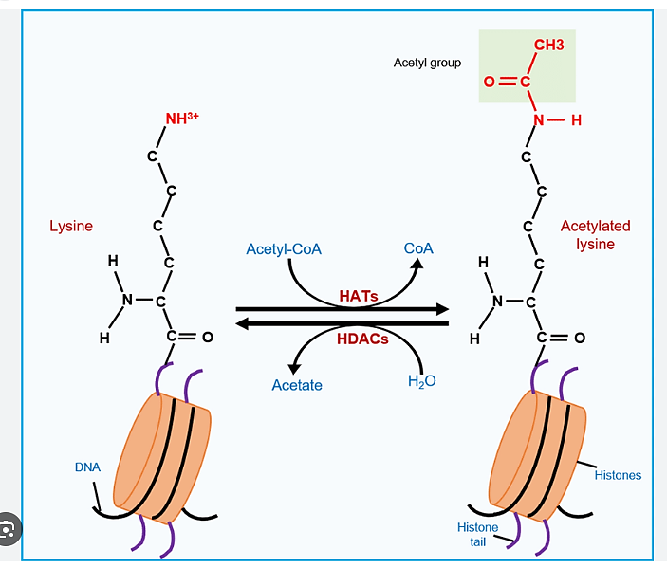

in histone tail

(<https://www.researchgate.net/publication/349664655/figure/fig2/AS:996051318214668@1614488548676/Regulation-of-histone-acetylation-dynamics-HATs-histone-acetyltransferases-transfer.png>)

|  |
| --- |
|  |

Notice that this figure has the opposite left-right orientation from the figure on the previous page.

(<https://www.researchgate.net/profile/Burcu-Biterge-Sut/publication/323913650/figure/fig1/AS:1026703971319812@1621796710909/The-conformational-transition-between-euchromatin-and-heterochromatin.png>)

The switch to euchromatin in the region of the hemoglobin gene is an example of an epigenetic change that plays a role in the differentiation of red blood cells. To help your students understand the term epigenetic, you may want to tell your students that “epi” is Greek for over, outside of, or around; this corresponds to the fact that epigenetic changes do not alter the sequence of nucleotides in the DNA. “The most compelling definition of epigenetics is the study of changes in gene function that are heritable through cell division, yet reversible, and that do not involve changes in DNA sequence… Parent cells use epigenetic marks to “tell” their daughter cells what type of cell they will become … Epigenetic processes are fundamentally important for cell identity, lineage determination… They explain how an identical set of genomic instructions can generate all the required cell types for the organism without the need, in most cases, to alter gene sequence.” (<https://www.frontiersin.org/articles/10.3389/fcell.2018.00130/full>)

|  |  |
| --- | --- |
| Transcription factors are proteins that initiate transcription and regulate the rate of transcription of genes. A single transcription factor often regulates the rate of transcription for multiple genes involved in the differentiation of a specific type of cell.[7]  The simplified figure above question 12 is appropriate for high school students. The figure on the right provides more information about the control of transcription. (In addition, this figure illustrates an alternate definition of a gene; in this definition, a gene includes only the coding region and excludes the promoter and other regulatory regions of the DNA.[8] ) | https://i2.wp.com/cms.jackwestin.com/wp-content/uploads/2020/03/Transcription-factor-binding.png?resize=921%2C1200&ssl=1 |

(<https://i2.wp.com/cms.jackwestin.com/wp-content/uploads/2020/03/Transcription-factor-binding.png?resize=921%2C1200&ssl=1>)

There are multiple interactions between transcription factors and epigenetic changes. For example, epigenetic mechanisms can help to start the transcription of genes that code for transcription factors.[9]

If you want to challenge your students, you can include the following question.

**13a.** Different transcription factors bind to the regulatory regions for different genes. The transcription factor that turns on transcription of the hemoglobin gene is found in cells that are developing into:

a. muscle cells

b. red blood cells

c. skin cells

d. all of these

**13b.** Explain your reasoning.

If your students are having trouble answering question 14, you can add the following hint.

(Hint: Think about how the hemoglobin proteins are made during differentiation of red blood cells.)

The figure below summarizes the development of red blood cells. The production of red blood cells begins with an HSC (hematopoietic stem cell = blood stem cell) in the bone marrow. In the subsequent stages, the precursors of red blood cells are immediately adjacent to nurse macrophages. The CFU-E (Colony Forming Unit-Erythroid) divides to produce lots of daughter cells. The daughter cells undergo cell differentiation, including synthesis of hemoglobin (Hb). After hemoglobin is made, the nucleus is ejected. After the nucleus is ejected, the developing red blood cell is called a reticulocyte. The reticulocyte moves into the bloodstream, where it ejects the other organelles to finish differentiating into a red blood cell.[10] The ejected nucleus with a small amount of cytoplasm is called a pyrenocyte; the pyrenocyte is ingested and digested by the nurse macrophage.

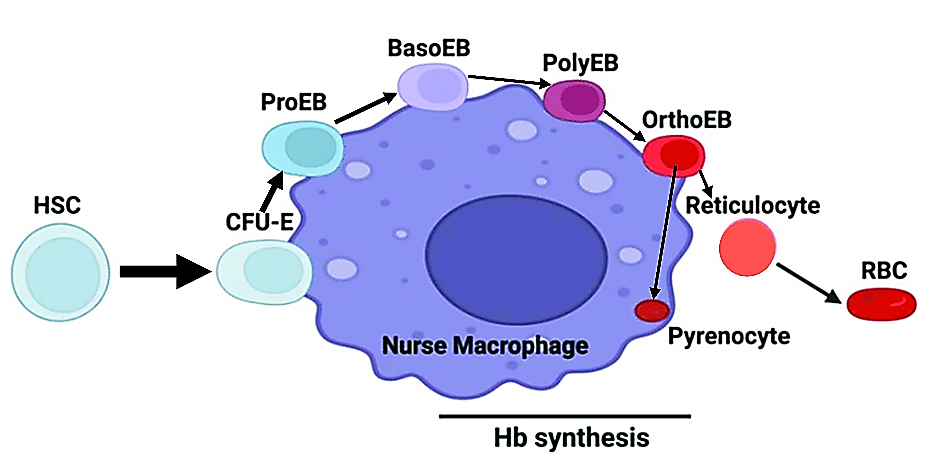

(modified from <https://www.researchgate.net/figure/Erythroid-differentiation-in-the-context-of-the-erythroblastic-island-niche-The-diagram_fig1_361840792>)

**Sources for Figures in Student Handout**

* Figure that shows red blood cell, modified from <https://my.clevelandclinic.org/-/scassets/images/org/health/articles/21788-continuous-capillary-illustration>
* Figure that shows how a blood stem cell gives rise to red blood cells, constructed by the author
* Figure that shows transcription and translation, modified from Krogh, Biology – A Guide to the Natural World
* Figure that shows RNA polymerase in action, modified from <https://i.pinimg.com/originals/b6/33/00/b63300d63b144cdd71c54a79d15cba92.jpg>
* Figure that shows ribosome function, modified from <https://upload.wikimedia.org/wikipedia/commons/a/a4/Multiple_Ribosomes_Translation_Protein_Synthesis.png>
* Figure that shows the effect of acetylation of histone proteins, modified from <https://rbej.biomedcentral.com/articles/10.1186/s12958-020-00637-5>
* Figure that shows the effect of a transcription factor, modified from <https://www.sciencelearn.org.nz/images/957-transcription-factor-binding-to-dna>

Other figures were constructed by the author.

**Related Learning Activities**

"Molecular Biology: Major Concepts and Learning Activities" (<https://serendipstudio.org/exchange/bioactivities/MolBio>)

Topics covered include understanding the important roles of proteins and DNA, DNA structure and replication, the molecular biology of how genes influence traits (including transcription and translation), and the molecular biology of mutations and genetic engineering. To help students understand the relevance of these molecular processes, the suggested learning activities link alleles of specific genes to human characteristics such as albinism, sickle cell anemia and muscular dystrophy.

1. By Dr. Ingrid Waldron, Department of Biology, University of Pennsylvania, © 2025. These Teacher Notes and the related Student Handout are available at <https://serendipstudio.org/exchange/bioactivities/RedBloodCells>.
2. Quotations from <https://www.nextgenscience.org/> and <https://www.nextgenscience.org/sites/default/files/HS%20LS%20topics%20combined%206.13.13.pdf>.
3. 98% of the total oxygen carried by the blood is reversibly bound to hemoglobin, and the other 2% is dissolved in the plasma and the water in red blood cells.
4. For a general introduction to the function of organelles in eukaryotic cells, see "Cells – How do they carry out the activities of life?" (<https://serendipstudio.org/exchange/bioactivities/Cells>). For a specific introduction to mitochondrial function, see "Using Models to Understand Cellular Respiration" (<https://serendipstudio.org/exchange/bioactivities/modelCR>).
5. Many of the other cells that have a short lifespan are subjected to frequent physical or chemical stressors (e.g. skin cells or the cells that line the inside of the digestive tract).
6. To introduce your students to mitosis, you may want to use the hands-on activity, “Mitosis and the Cell Cycle – How a Single Cell Developed into the Trillions of Cells in a Human Body” (<https://serendipstudio.org/sci_edu/waldron/#mitosis>) or the analysis and discussion activity, “Mitosis and the Cell Cycle – How the Trillions of Cells in a Human Body Developed from a Single Cell” (<https://serendipstudio.org/exchange/bioactivities/MitosisRR>).
7. A good introduction to transcription factors is <https://www.khanacademy.org/science/ap-biology/gene-expression-and-regulation/regulation-of-gene-expression-and-cell-specialization/a/eukaryotic-transcription-factors>.
8. For a reference that uses the definition of a gene that is used in this activity, see <https://www.ncbi.nlm.nih.gov/books/NBK12983/#:~:text=The%20promoter%20(with%20or%20without,a%20linear%20polymer%20of%20nucleotides>.
9. Obviously, development involves much more than mitosis and cell differentiation. Information about other processes involved in development is available at:

   * <http://www.scholarpedia.org/article/Morphogenesis>
   * <http://www.healthofchildren.com/P/Prenatal-Development.html>
   * <https://en.wikipedia.org/wiki/Prenatal_development>
   * <https://www.youtube.com/watch?v=bEgygtbEo2A&feature=youtu.be>

  
10. For more information, you may want to show your students the first part or all of the 5-minute video, "Understanding Erythropoiesis" (<https://www.youtube.com/watch?v=cMqwV9Vb4_Y>).